Highland names new men's bowling head coach
5/24/2017
FREEPORT -- Highland Community College has named Kris Beach as the new Highland Cougar Men's Bowling head coach.
Beach comes to the Cougars after spending four seasons as an assistant bowling coach at the University of Wisconsin-Whitewater. Prior to his tenure at UW-Whitewater, he served as head coach at University of Central Missouri and Western Illinois University. Beach finished last season assisting the HCC team during the year-end tournament championship run for the Cougars.
Beach is a 2009 graduate of University of Central Missouri with a Bachelor of Science in Chemistry with a triple minor in forensic science, mathematics, and criminal justice.
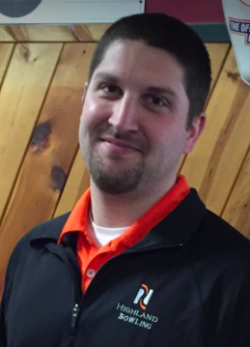

“I am very excited for this opportunity as head coach of the Highland Men’s Bowling program,” said Beach. “I am eager to work alongside the Director of Bowling, Jeff Johnson, to continue growing this program into a NJCAA powerhouse. After a very successful season last year, I await the opportunity to work with the returners and incoming student-athletes on surpassing our accomplishments on the lanes and in the classroom for years to come.”
Highland Director of Bowling, Jeff Johnson, shared his excitement about the next Cougar Bowling head coach. “Kris has been part of top-level competition at the Collegiate level for many years and knows what is involved in winning not only in the classroom but on the lanes. We have recruited top talent to HCC each year and we are building one of the top programs in the nation. I am confident that Kris will continue the Cougar pride of winning and has the personality that our players will feed off of to be better teammates both on and off the lanes.”
Highland Athletic Director, Pete Norman, is looking forward to addition of Beach as the Head Coach of Men’s Bowling. “I am excited to have Kris lead this program. As a Freeport native and resident, this seems like a perfect fit, and with his experience I am confident that the program is in good hands. I know our bowlers will rally around Kris as a leader and he will build strong and impactful relationships with our student-athletes. I look forward to Cougar Nation embracing Coach Beach.”
________________________
Highland Community College Athletics – Cougar Bowling Teams
2998 W. Pearl City Road
Freeport, IL 61032-9341
815-235-6121
Fax 815-235-6130

Highland Athletic Director – Pete Norman – 815/599-3465
Director of Bowling – Jeff Johnson – 815/238-8707
Highland Bowling Men’s Head Coach – Kris Beach – 815/275-0969

