“You can’t use up creativity. The more you use, the more you have.” ― Oscar Wilde

Friday Forums will be held at noon on selected Fridays.

Present at a Friday Forum!
Presenters may include:
- Students
- Student groups
- HCC Faculty & Staff

Presentations might be:
- Art works
- Dramatic presentations
- Music recitals
- Poetry reading
- Research demonstration
- Share your knowledge!
- Poster session
- Any subjects!
- Your ideas here!

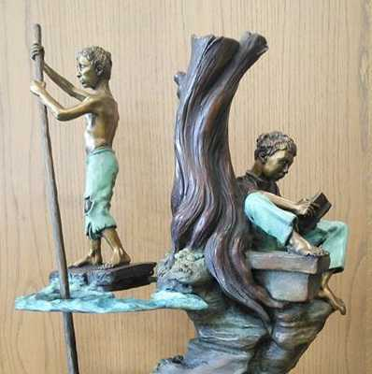

“Creativity is contagious. Pass it on!”

--Albert Einstein

Ph 815.599.3539
library@highland.edu

2998 W Pearl City Road
Freeport IL 61032

http://www.highland.edu/library

Clarence Mitchell Library
research | learning | knowledge

Friday Forums

Clarence Mitchell Library Presents
Friday Forums
student/faculty/staff application
Apply today for an opportunity to perform or present your scholarly or creative work to the public.
Friday Forums are offered to encourage idea sharing and community participation.
2018-2019 Events will be on selected Fridays at noon.
Individuals or groups of HCC students, classes, faculty or staff may present work for the campus community.
Friday Forums opportunities will be offered up to monthly during Fall 2018 and Spring 2019 semesters.

Presentations may include such work as dramatic or spoken works, poster sessions or oral presentation of academic work, musical performances, or may feature visual arts. Other ideas are welcomed! Visual art exhibits may remain in the library exhibit space for up to two weeks following the Friday Forum. Up to four proposals for Friday Forums events will be selected for each semester. If you are among the selected applicants, the library will work with you in planning and promoting your Friday Forums event. Application review is ongoing. Submit your ideas anytime!
Contact Laura Watson with your questions: laura.watson@highland.edu
815-599-3456.
Applicant(s) Name(s):____________________________________________________________________________________________________
________________________________________________________________________________________________________________________________________________
E-mail:_____________________________
Phone:_____________________________
Description of event proposed (please include an estimated length of the program): ____________________________________________________________________________________________________________________________________________________________________________________________________________________________________________________________________________________________________________________________________________________________________________________________________________________________________
Suggest dates (Fridays) that will work for you. Final dates will be selected in consultation with applicants and considering library facility and staff availability:
___________________________________
Library use: Selected? Yes No Date assigned:____________________

