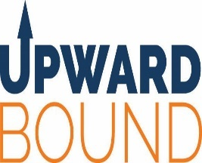
The Upward Bound Program
2998 West Pearl City Road
Freeport, IL 61032
(815)599-3489
UpwardboundFreeport@gmail.com

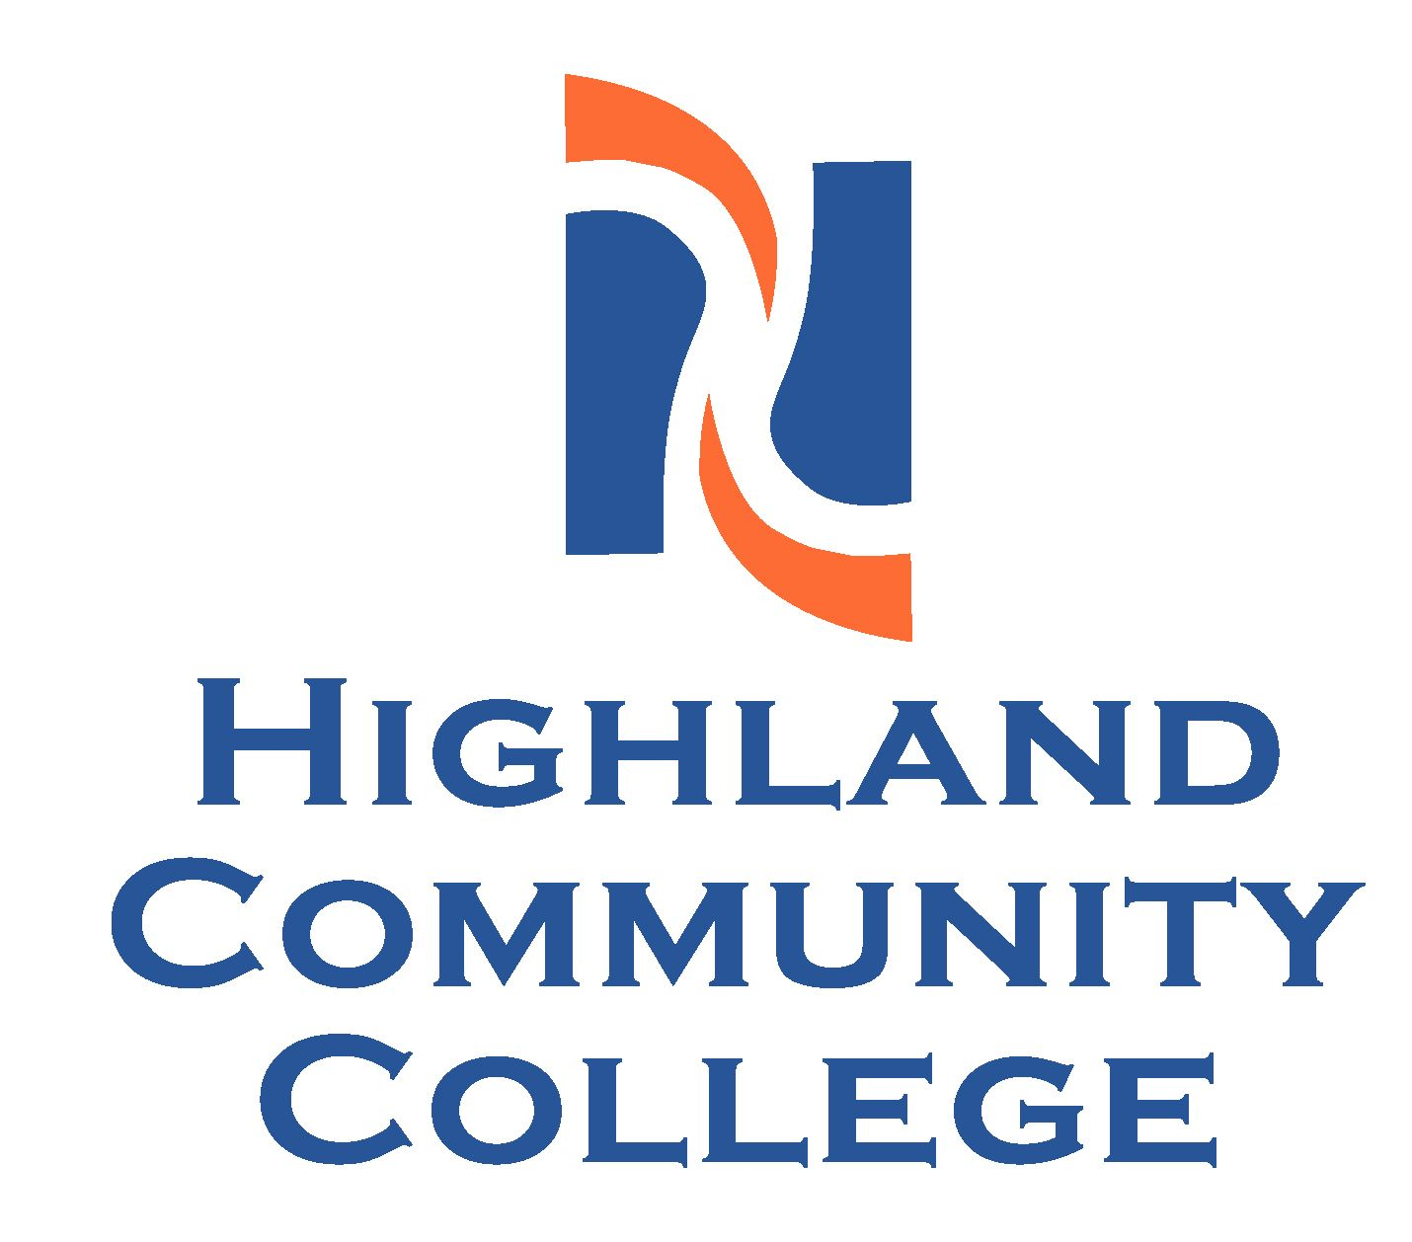
Application Form
Please ensure that all parts of the application are completed and signed.
This form must be completed using blue or black ink.
Information about the Student
Name: Do you intend to go to college? Yes Unsure
High School: ___________________ Current Grade: 9th 10th 11th 12th Expected Graduation Year: ________
Mailing Address: __________________________________________ Home Phone Number: ___________________________
Student Phone Number: __________________________ Student Email Address:____________________________________ Gender: Male Female Birth date: ______________________ Social Security Number: - ___-__________
US Citizen: Yes No
Ethnicity: Are you Hispanic or Latino? Yes No
Race (please check all that apply): American Indian/Alaskan Native Asian White Other: _____________
Black/African American Native Hawaiian or Other Pacific Islander

With whom does the student live? Please check only one: Both parents Mother Father Legal Guardian
Foster Care Other (please specify) __________________
Parents/Guardians martial status: Married, living together Married, living separately Single Divorced
Mother/Legal Guardian Information | Father/Legal Guardian Information
Name: ___________________________________________  Work Phone Number: _______________________________  Cell Phone Number: ________________________________  Best Time to Contact: _______________________________  Living Deceased  Has Mother/Legal Guardian Earned a 4 Year College Degree?  Yes No | Name: ___________________________________________  Work Phone Number: _______________________________  Cell Phone Number: ________________________________  Best Time to Contact: _______________________________  Living Deceased  Has Father/Legal Guardian Earned a 4 Year College Degree?  Yes No
How do you feel about your student participating in this program?
Financial Information
Did the parents file an Income Tax Return for 2020? No Yes (If yes, please include a copy of all pages of the FEDERAL return)
What was your Taxable Income for Tax Year 2020: $ ____________________ For Form 1040 this line is 43; for Form 1040A this line 27; for Form 1040EZ this is line 6. If you were not required to file a Federal Tax Return, your Taxable income is $0. If applying after December 31, 2021, you must provide information referencing Tax Year 2021.
*TRIO Income Guidelines: (Taxable Income as of January 13, 2021) Family Size: (1) $19,320 (2) $26,130 (3) $32,940 (4) $39,750
(5) $46,560 (6) $53,370 (7) $60,180 (8) $66,990
*Total number of members in household: __________ (9) $73,800 (10) $80,610

The information contained in this application is for the use of the Upward Bound Program at Highland Community College only, and held in the strictest confidence. All records are kept in secure locked storage. By signing below, you certify that all information contained in this application is correct, complete and accurate (this includes the educational attainment level of both parents, financial information, size of household, etc.) to the best of your knowledge by signing below.

Parent/Guardian Signature ________________________________ Name (please print) _________________Date__________
Student Signature __________________________________ Name (please print) ______________________Date_________

Application Form (continued)
Please ensure that all parts of the application are completed and signed.
This form must be completed using blue or black ink.
AUTHORIZATION FOR RELEASE OF EDUCATIONAL RECORDS & ADDITIONAL RELEASES
Please read the following information before signing. All information will be kept confidential.
I hereby grant authorization my educational records (grades, transcripts and test scores) to be released to the Upward Bound Program at Highland Community College. I understand that the Upward Bound Program will request grades at the conclusion of each grading period and transcripts/test scores at least annually. I furthermore agree that the Upward Bound Program may share academic information regarding participation in the Upward Bound Program (grades, test scores etc.) with my parents and or high school.  I also authorize the Upward Bound program at Highland Community College to use photographs and/or videotape with my image in Upward Bound publications and/or news releases.  Permission is granted for the student to participate in all activities sponsored or attended by HCC. Permission is granted for Upward Bound staff members to transport the above student to and from these activities.  Permission is granted to provide counseling services to the above name student as necessary by the appropriate Institution and/or community resources.  Permission is granted for Upward Bound staff (Director, Academic Coordinator, Program Specialist, Administrative Assistant, to provide over-the- counter medications (acetaminophen, aspirin, Pepto-Bismol, ibuprofen, Sudafed, decongestants, antihistamines etc.) for minor physical complaints. | We understand that the Upward Bound Program is for students who are able to handle the responsibility of being away from home during over-night college visits.  We recognize that Upward Bound Program is a major investment by the United States Department of Education and we understand that if the student is accepted and wishes to attend, he or she will be expected to fully participate in the program (both during the academic year and summer academy).  We understand that although travel costs, stipends, room, board and fees are provided free of charge, the student’s family or guardian must assume responsibility for illnesses (including prescription coverage) or pre-existing conditions, medical release forms and any information needed to complete them.  We understand that if Highland Community College accepts the applicant, he or she have to adhere to the program’s rules and regulations concerning student’s responsibility and behavior in the academic program. We understand that the Upward Bound Director will have the right to dismiss any student whose behavior is incompatible with the goals and standards of Highland Community College.  We agree that the student, if accepted into the Upward Bound program, may participate in answering questionnaires/surveys and other appropriate and approved research projects done as part of the program’s evaluation.

Highland Community College, the Upward Bound Program, nor any staff member will be held responsible for any injuries
or obligations resulting from these activities.

Activities for which permission is NOT granted: _______________________________________________________________
Over the counter medication NOT to be administered: ___________________________________________________________
Please list the names of two high school teachers (only list teacher of these subjects: English, math, social studies, or science)
who will be asked to provide a reference for this student:

Teacher 1: Subject: ________________________________
Teacher 2: Subject: _____________________________

By signing below, you are agreeing to all statements on this page, as well as providing permission for the Upward Bound Program at Highland Community College to acquire recommendation forms from the two teachers named above.

Parent/Guardian Signature __________________________Name (please print) _______________________Date________

Student Signature _________________________________ Name (please print) _______________________Date________

The Upward Bound Program
2998 West Pearl City Road
Freeport, IL 61032
(815)599-3489
UpwardboundFreeport@gmail.com

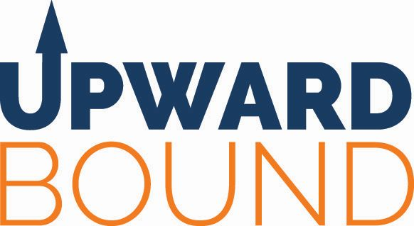
Counselor Recommendation Form
Please ensure that all parts of the application are completed and signed.
The student listed below is applying to join the Upward Bound Program at Highland Community College. We seek recommendations from a guidance counselor at the school the student attends to ensure that we are admitting the best students to our program. The questions on this recommendation will help us assess the student’s willingness and ability to attend all services offered as well as to learn more about their academic ability. We appreciate your honest and candid answers to all questions, and all information on this form will be held in confidence.
Please add this recommendation to the student’s application, and get to the Upward Bound office as directed by the UB staff member who serves your school. If you have any questions, please contact our office using the contact information listed in the header of this form.
General Information
Student Name: _________________________________________ School: _________________________________
Academic Information
Please check if the student completed the following courses by the end of 8th grade: Pre-Algebra Algebra Geometry
Student achieved a GPA of 2.5 or higher for the most recent school year? Yes No
Does the student have an IEP? Yes No
Proficiency in Math MAP Score? Yes No
Proficiency in Reading MAP Score? Yes No
Recommendation

Would you recommend admitting this student to Upward Bound? Yes No
Explanation of your recommendation: _________________________________________________________________
_____________________________________________________________________________________________
Please rate the student on each of the following:

Academic Performance Excellent Good Fair Poor
Motivation Excellent Good Fair Poor
Maturity Excellent Good Fair Poor
Dependability and Reliability Excellent Good Fair Poor
Problem Solving Skills Excellent Good Fair Poor
Attendance Excellent Good Fair Poor

Is this student interested in attaining a 4 year college/university degree? Yes No Unsure
Do you feel this student has the ability/potential to do college level work? Yes No Unsure
Do you feel this student would attend: School Visits Yes No Unsure
Saturday Return Trips Yes No Unsure
Summer Academy Yes No Unsure
What are some challenges this student face in preparing for getting, admitted to and succeeding in education after high
school? __________________________________________________________________________________________
Counselor Signature ____________________________________________ Date ___________________________

The Upward Bound Program
2998 West Pearl City Road
Freeport, IL 61032
(815)599-3489
UpwardboundFreeport@gmail.com

Teacher Recommendation Form
Please ensure that all parts of the application are completed and signed.
The student listed below is applying to join the Upward Bound Program at Highland Community College. We seek recommendations from two teachers and a guidance counselor at the school the student attends to ensure that we are admitting the best students to our program.
Upward Bound is operated under grants from the US Department of Education, and our ultimate goal is to prepare students to enter and complete postsecondary education. Everything we do is at no cost to the student’s family. We offer many services, including: school visits at target high schools, college visits, cultural trips, and a six-week Summer Academy at Highland Community College during the months of June and July. The questions on this recommendation will help us assess the student’s willingness and ability to attend all services offered as well as to learn more about their academic ability. We appreciate your honest and candid answers to all questions, and all information on this form will be held in confidence.
Please return this recommendation to the counseling office, and the guidance counselor will add it to the student’s application. You can also return this recommendation in the attached reply envelope, if applicable. If you have any questions, please contact our office using any of the contact information listed on this form.
General Information
Student Name: _____________________________________________ School: ______________________________
Teacher Name: _______________________________ Subject in which you’ve taught student: _________________
Recommendation
Would you recommend admitting this student to Upward Bound? Yes No
Explanation of your recommendation: _________________________________________________________________________
_________________________________________________________________________________________________________
_________________________________________________________________________________________________________

Please rate the student on each of the following:

Academic Performance Excellent Good Fair Poor
Motivation Excellent Good Fair Poor
Maturity Excellent Good Fair Poor
Dependability and Reliability Excellent Good Fair Poor
Problem Solving Skills Excellent Good Fair Poor
Attendance Excellent Good Fair Poor

Is this student interested in attaining a 4 year college/university degree? Yes No Unsure
Do you feel this student has the ability/potential to do college level work? Yes No Unsure
Do you feel this student would attend: School Visits Yes No Unsure
Saturday Return Trips Yes No Unsure
Summer Academy Yes No Unsure
What are some challenges this student face in preparing for getting, admitted to and succeeding in education after high school? ____________________________________________________________________________________________________
____________________________________________________________________________________________________

Teacher Signature ____________________________________________ Date ___________________________
The Upward Bound Program
2998 West Pearl City Road
Freeport, IL 61032
(815)599-3489
UpwardboundFreeport@gmail.com

Teacher Recommendation Form
Please ensure that all parts of the application are completed and signed.
The student listed below is applying to join the Upward Bound Program at Highland Community College. We seek recommendations from two teachers and a guidance counselor at the school the student attends to ensure that we
are admitting the best students to our program.
Upward Bound is operated under grants from the US Department of Education, and our ultimate goal is to prepare students to enter and complete postsecondary education. Everything we do is at no cost to the student’s family. We offer many services, including: school visits at target high schools, college visits, cultural trips, and a six-week Summer Academy at
Highland Community College during the months of June and July. The questions on this recommendation will help us assess the student’s willingness and ability to attend all services offered as well as to learn more about their academic ability.
We appreciate your honest and candid answers to all questions, and all information on this form will be held in confidence.

Please return this recommendation to the counseling office, and the guidance counselor will add it to the student’s application. You can also return this recommendation in the attached reply envelope, if applicable. If you have any questions, please contact our office using any of the contact information listed on this form.
General Information
Student Name: _____________________________________________School: __________________________
Teacher Name: _______________________________ Subject in which you’ve taught student: _____________
Recommendation
Would you recommend admitting this student to Upward Bound? Yes No
Explanation of your recommendation: __________________________________________________________
____________________________________________________________________________________________

Please rate the student on each of the following:

Academic Performance Excellent Good Fair Poor
Motivation Excellent Good Fair Poor
Maturity Excellent Good Fair Poor
Dependability and Reliability Excellent Good Fair Poor
Problem Solving Skills Excellent Good Fair Poor
Attendance Excellent Good Fair Poor

Is this student interested in attaining a 4 year college/university degree? Yes No Unsure
Do you feel this student has the ability/potential to do college level work? Yes No Unsure
Do you feel this student would attend: School Visits Yes No Unsure
Saturday Return Trips Yes No Unsure
Summer Academy Yes No Unsure
What are some challenges this student face in preparing for getting, admitted to and succeeding in education after high school? ___________________________________________________________________________________________
__________________________________________________________________________________________________

Teacher Signature __________________________________________ Date ___________________
The Upward Bound Program
2998 West Pearl City Road
Freeport, IL 61032
(815)599-3489
UpwardboundFreeport@gmail.com

Applicant Interview Form
Please ensure that all questions are asked; answer as the student responds.
This form must be completed using blue or black ink.
General Information
Student Name: ________________________________ School: ______________________________________
Interviewer: __________________________________ Title: ______________________________ Date:_______________
Interview Questions
1a. Why are you interested in going to college? __________________________________________________________
_________________________________________________________________________________________________
1b. If you are interested in going to college, what are your plans for after high school? __________________________
_________________________________________________________________________________________________
2. What do you hope to gain by participating in Upward Bound: how do you feel UB will help you reach your college goal? ____________________________________________________________________________________________
_________________________________________________________________________________________________
3. Why should you be chosen to participate in Upward Bound? ______________________________________________
What sets you apart from other candidates? __________________________________________________________
_________________________________________________________________________________________________

4. What would you like to study in college? _____________________ What about this field interest you? ___________
_________________________________________________________________________________________________
What career do you hope to attain after studying this in college? ____________________________________________

5. What college would you like to attend and why? _______________________________________________________
_________________________________________________________________________________________________
6. What subjects do you enjoy in school now that you want to study in college? ________________________________
_______________________________________________________________________________________________
7. What makes you nervous about going to college? financial aid family responsibilities lack of motivation
social being away from home money/need to work
other: _______________________________________________
8. What other responsibilities do you have other than school? _______________________________________________
9. Do you currently participate in any other college program? Yes No if so, which ones: _____________________
10. How do your parents/guardians feel about: your desire to go to college? supportive unsupportive
You participating in UB? supportive unsupportive
11. How committed are you in all UB activities (college visits, Saturday Academies, cultural visits, FAFSA, SAT prep) if you are admitted to UB? Very committed Partially committed Unsure Not committed
12. Do you have any specific concerns about your ability to participate in the program?
family support employment extracurriculars health issues other: _____________________________

13. How much time do you devote to your studies on a daily basis? _______ hours ____________ minutes
14. Do you have any questions before we conclude the interview? _____________________________________________
___________________________________________________________________________________________________
___________________________________________________________________________________________________

